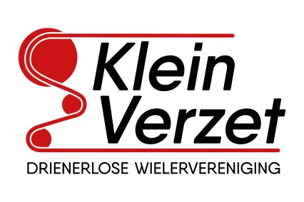
Bank: IBAN: NL09 RABO 0316 7983 04
BIC: RABONL2U
KvK: 40074707
Aangesloten bij de K.N.W.U., Koninklijk erkend sinds 1973

D.W.V. Klein Verzet
Secretariaat: Postbus 217
7500 AE Enschede
penningmeester@kleinverzet.utwente.nl

DECLARATIONFORM

Please fill out this form completely and legibly. All claims must be accompanied by a receipt. Attach the receipts to the form so that they do not get lost. Date the form and do not forget to sign it. Deposit this form in the Klein Verzet mailbox in the Sports Center or hand it to the treasurer. In case of online claims, this form must be completed in full, including a clear copy of the receipt, and mailed to the treasurer.
Name:
Adress:
Residence:
Bank- or gironumber:

Description | Date | Amount
 |  | €
 |  | €
 |  | €
 |  | €
 |  | €
Total |  | €

Date:
Signature:

Do not fill in below
Payed: |  | on |  | per bank
Signature Treasurer:

