Bank: IBAN: NL09 RABO 0316 7983 04  
 BIC: RABONL2U  
KvK: 40074707  
Aangesloten bij de K.N.W.U., Koninklijk erkend sinds 1973

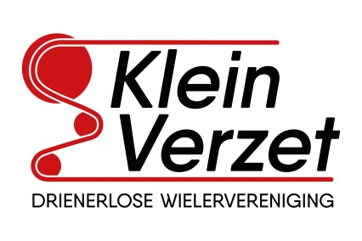

**D.W.V. Klein Verzet**

Secretariat: Postbus 217  
 7500 AE Enschede  
penningmeester@kleinverzet.utwente.nl

**DECLARATION FORM**

Fill in this form clearly. The proofs of payment should be added on the second page, after which this form can be enlarged to a PDF and can be sent to penningmeester@kleinverzet.utwente.nl If you drive with your own car, a mileage allowance applies.

**Note**: If the proofs of payment are sent separately, the treasurer may accept the declaration.

|  |  |
| --- | --- |
| Name: |  |
| Adress: |  |
| City: |  |
| Bank- or gironumber: |  |

|  |  |  |  |  |
| --- | --- | --- | --- | --- |
| Milage allowance | | | | |
| Start distance | End distance | Milage | Price per KM | Amount |
|  |  |  | 0.075 | € |

|  |  |  |
| --- | --- | --- |
| Description | Date | Amount |
|  |  | € |
|  |  | € |
|  |  | € |
|  |  | € |
|  |  | € |
|  |  | € |
| Totaal | | € |

|  |  |
| --- | --- |
| Date: |  |
|  |  |
|  |  |
| Signature: |  |

Receipts, bank statements, proof of payment: on the back